|  |  |
| --- | --- |
| download | COMSATS University Islamabad, Vehari Campus Department of Computer Science |

**Class: BSCS-SP22-4B Date: 23 Oct 2023**

**Subject: Data Structure & Algorithm Lab Instructor: Yasmeen Jana Max Marks: 25 Reg. No: SP22-BCS-087**

**Max Time: 90 Minutes Name: Mubashir Nadeem**

Email: [yasmeenjana@cuivehari.edu.pk](mailto:yasmeenjana@cuivehari.edu.pk)

## Activity 1:

Write a C++ code to create a singly linked list using "SLL()" function and Remove duplicates from an unsorted linked list as RemoveDup() function and display linked list with unique values. **(15)**

For Example:

Input: linked list = 12->11->12->21->41->43->21

Output: 12->11->21->41->43.



Hint:

Use two loops, Outer loop is used to pick the elements one by one and the Inner loop compares the picked element with the rest of the elements.

**CODE**

/* C++ Program to remove duplicates in an unsorted linked list */

#include <iostream>

using namespace std;

struct Node {

int data;

struct Node* next;

};

// Utility function to create a new Node

struct Node* newNode(int data)

{

Node* temp = new Node;

temp->data = data;

temp->next = NULL;

return temp;

}

/* Function to remove duplicates from a

unsorted linked list */

void removeDuplicates(struct Node* start)

{

struct Node *ptr1, *ptr2, *dup;

ptr1 = start;

/* Pick elements one by one */

while (ptr1 != NULL && ptr1->next != NULL) {

ptr2 = ptr1;

/* Compare the picked element with rest

of the elements */

while (ptr2->next != NULL) {

/* If duplicate then delete it */

if (ptr1->data == ptr2->next->data) {

/* sequence of steps is important here */

dup = ptr2->next;

ptr2->next = ptr2->next->next;

delete (dup);

}

else /* This is tricky */

ptr2 = ptr2->next;

}

ptr1 = ptr1->next;

}

}

/* Function to print nodes in a given linked list */

void printList(struct Node* node)

{

while (node != NULL) {

printf("%d ", node->data);

node = node->next;

}

}

// Driver code

int main()

{

/* The constructed linked list is:

10->12->11->11->12->11->10*/

struct Node* start = newNode(10);

start->next = newNode(12);

start->next->next = newNode(11);

start->next->next->next = newNode(11);

start->next->next->next->next = newNode(12);

start->next->next->next->next->next = newNode(11);

start->next->next->next->next->next->next = newNode(10);

printf("Linked list before removing duplicates ");

printList(start);

removeDuplicates(start);

printf("\nLinked list after removing duplicates ");

printList(start);

return 0;

}

**OUTPUT**

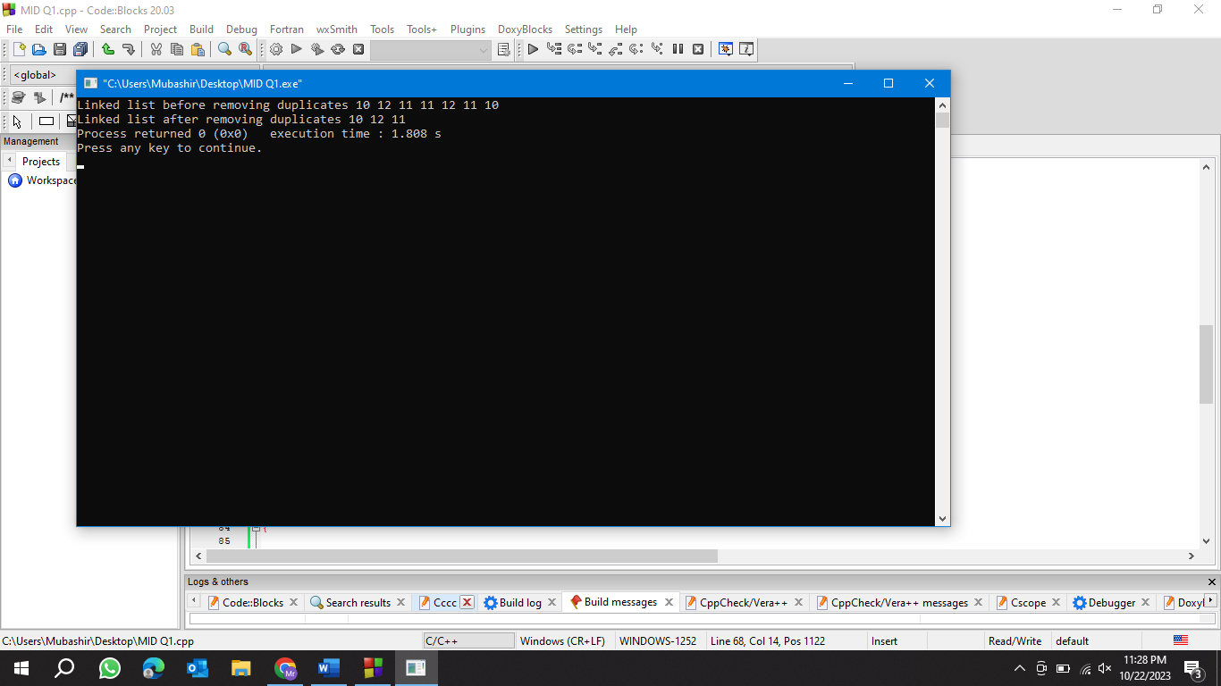

## Activity 2:

Write a C++ code to create a Queue using a linked list. The code should contain functions for Enqueue(), Dequeue(), and Display(). **(10)**

**CODE**

#include<iostream>

using namespace std;

struct Node

{

int data;

Node *next ;

};

class Queue

{

Node *front, *rear;

public:

Queue()

{

front = rear = NULL; // Initially

}

void Enqueue(int elem) // for insertion from rear

{

Node *newnode;

newnode = new Node;

newnode->data = elem;

newnode->next = NULL;

if(front == NULL)

front = rear = newnode;

else

{

rear->next = newnode;

rear = newnode;

}

}

void Dequeue() // for deletion from front

{

Node *temp;

if(front == NULL)

cout<<"Queue is Empty";

else

{

temp= front;

front = front->next;

delete temp;

}

}

void display()

{

Node *temp;

temp= front;

cout<<"The Elements in the QUEUE are : ";

while(temp!=NULL) // (temp!= rear->next)

{

cout<<temp->data<<"\t";

temp = temp->next;

}

cout<<endl;

}

};

int main()

{

Queue Q1;

Q1.Enqueue(10);

Q1.Enqueue(20);

Q1.Enqueue(23);

Q1.Enqueue(44);

Q1.display();

cout<<"\n";

Q1.Dequeue();

cout<<"Queue after Dequeue the first Element :"<<endl;

Q1.display();

}

**OUTPUT**

